Sponge: Social Story

This story may help your child know what to expect when they come to see Sponge the Show.

This week/next week I am going to the theatre with …./I am going to see a show called Sponge.

I will go by car/bus, just like how I get to school/when I are with mum and dad/my bus driver.

I will go into the door and there will be lots of other children and their families, it might be really noisy.
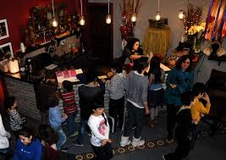

When it is time for the show to start I will go through the door to the stage and it will look like this:

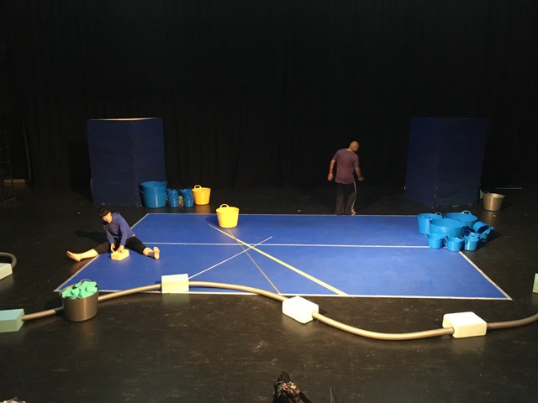

This is Louise and Shane who are dancers.
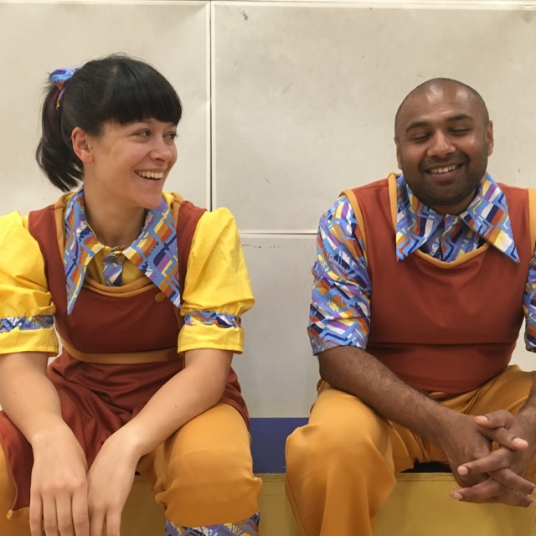

We’ll take off ours shoes and socks if that feels OK.

Then we’ll watch the show.

Louise wants to play but Shane would like her to be tidy and also go to bed
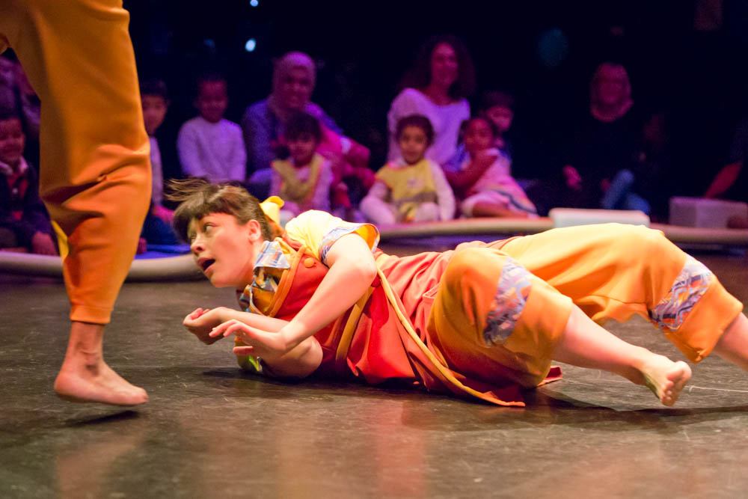

Louise and Shane will be playing and dancing with lots of sponges.
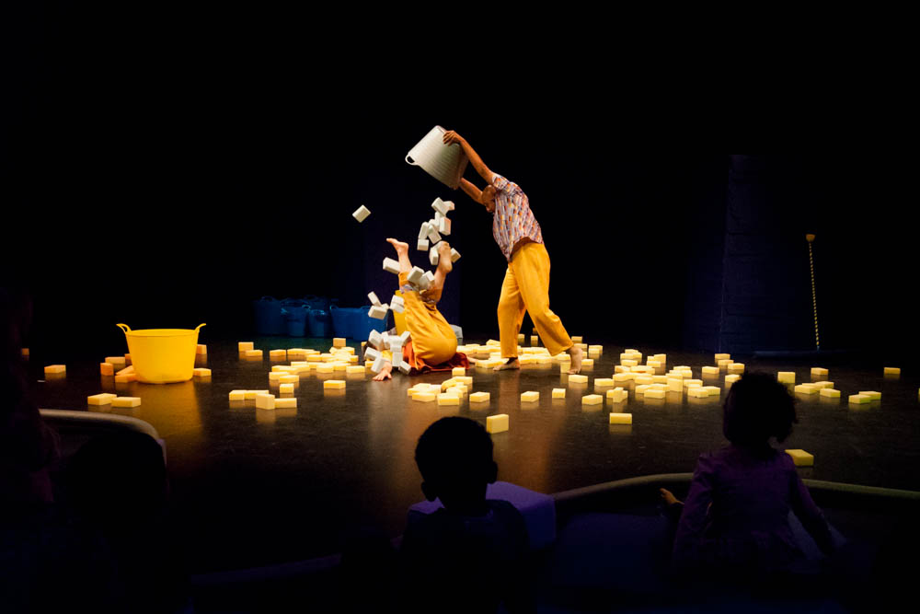
And there will be music, sometimes it will be loud.

Sometimes the lights will be low and sometimes they will be bright.

I can join in and play when Louise says it’s OK, then I get to touch the sponges and to roll, squeeze and squash sponges.
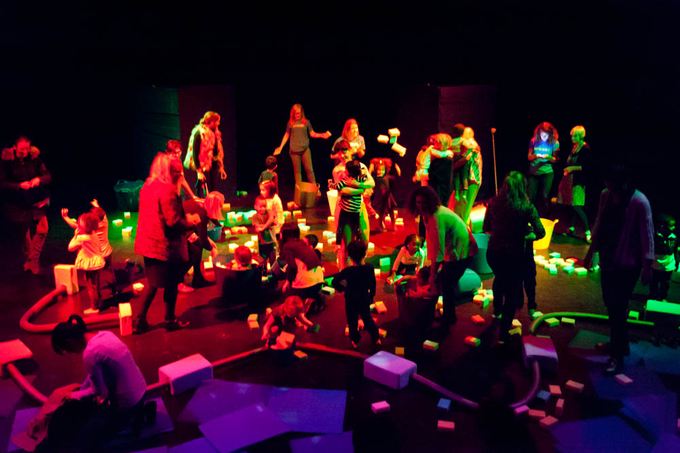

My teacher/parent will stay with me and play with me. They will help me know what to do and when it’s OK to be on stage with Shane and Louise.

I may like going inside a tub and having lots of Sponges poured over me.
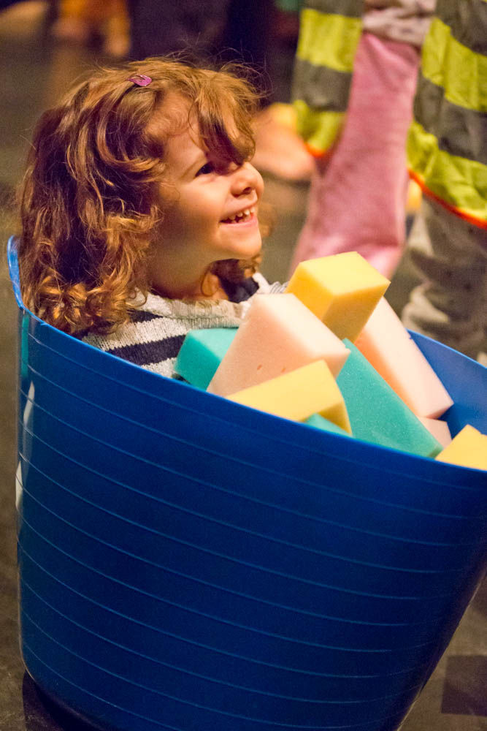

Then it will be time to tidy up and we’ll put all the sponges into the tubs.

I will put on my shoes and socks and leave the theatre.

